Design Requirements

1. Each independently recovered launch vehicle body anticipated to reach an apogee above 1,500 ft (457 m) above ground level (AGL) shall follow a "dual-event" recovery operations concept (CONOPS), including an initial deployment event and a main deployment
2. The initial deployment event shall occur at or near apogee, stabilize the vehicle's attitude, and reduce its descent rate enough to permit the main deployment event yet not so much as to exacerbate wind drift.
3. The main deployment event shall occur at an altitude no higher than 1,500 ft AGL and reduce the vehicle's descent rate sufficiently to prevent excessive damage upon impact with ground.
4. At least one redundant recovery system electronics subsystem shall implement a COTS flight computer
5. The recovery system shall implement adequate to prevent hot ejection gases from causing burn damage to retaining chords, parachutes, and other vital components as the specific design demands.

Dual Deployment – Dual Detachment

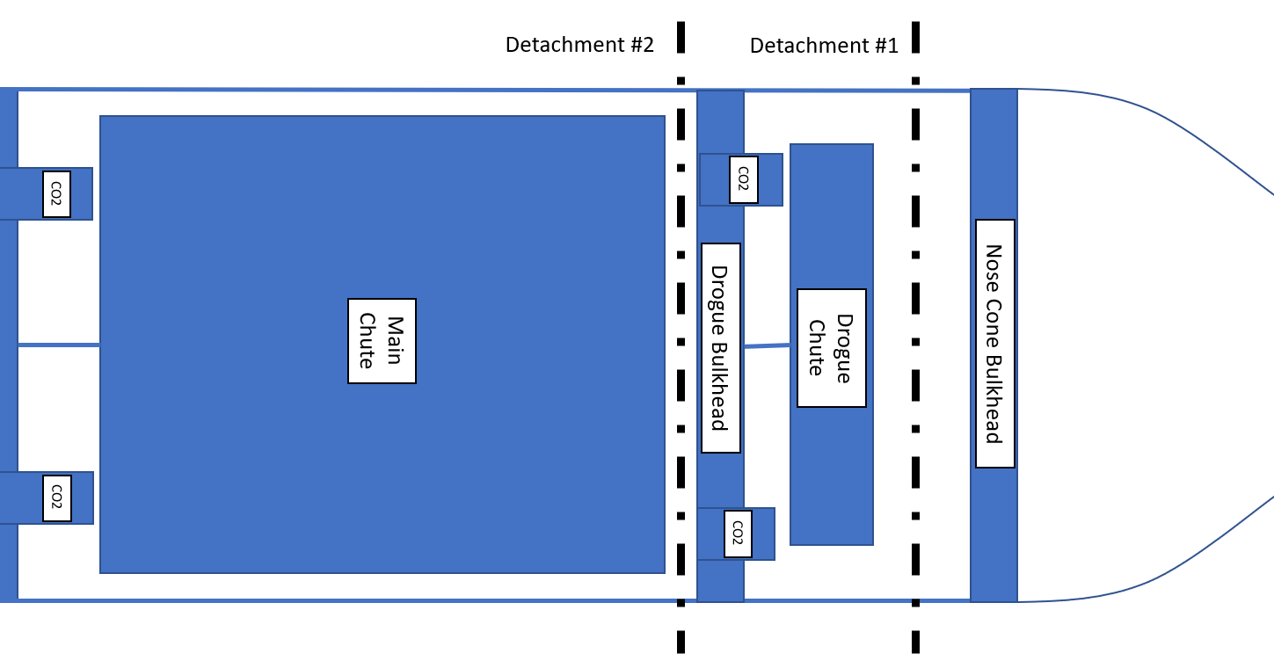

Components:

|  |  |  |  |
| --- | --- | --- | --- |
| Component | Quantity | Price per Component | Total Price |
| CO2 Raptor | 4 | $158.00 | $632.00 |
| 30” Elliptical Parachute | 1 | $71.00 | $71.00 |
| 120” Iris Ultra Standard Parachute | 1 | $432.46 | $432.46 |
| Bulkheads | 1 |  |  |
| TeleMega | 1 | $400 | $400 |
| StratoLogger | 1 | $69.95 | $69.95 |
| Tender Descender | 1 | $80 | $129 |
| Deployment Bag | 1 | $49.95 | $49.95 |
| Total: |  |  | $1704.36 |

Dual Deployment – Single Detachment

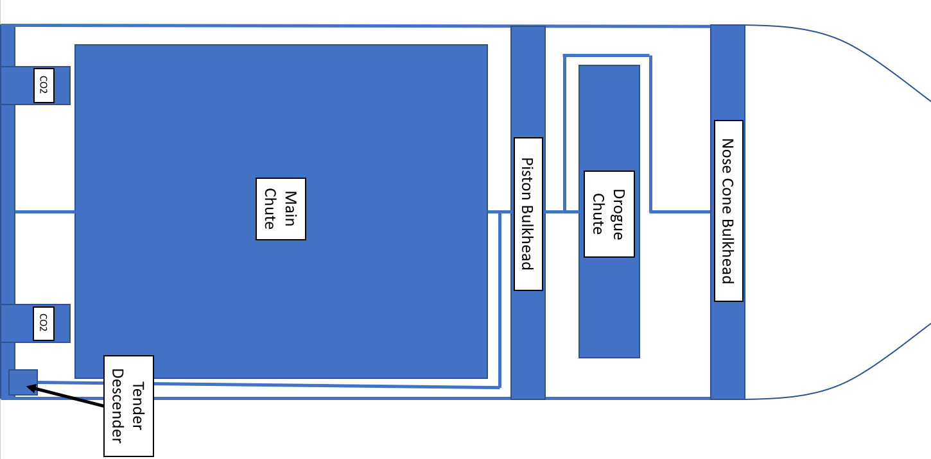

Components:

CO2 Raptor – x2 ($158.00 [Total: $236.00])

30” Elliptical Parachute – x1 ($71.00)

120” Iris Ultra Standard Parachute – x1 ($432.46)

Bulkheads – x1 (Price Unknown)

TeleMega – x1 ($400)

StratoLogger – x1 ($69.95)

Tender Descender – x1

|  |  |  |  |
| --- | --- | --- | --- |
| Component | Quantity | Price per Component | Total Price |
| CO2 Raptor | 2 | $158.00 | $236.00 |
| 30” Elliptical Parachute | 1 | $71.00 | $71.00 |
| 120” Iris Ultra Standard Parachute | 1 | $432.46 | $432.46 |
| Bulkheads | 1 |  |  |
| TeleMega | 1 | $400 | $400 |
| StratoLogger | 1 | $69.95 | $69.95 |
| Tender Descender | 1 | $80 | $129 |
| Deployment Bag | 1 | $49.95 | $49.95 |
| Total: |  |  | $1388.36 |

Analyses

The recovery system in the rocket is one of the most important systems in the rocket, it is what sets our designed rocket apart from a ballistic missile. Due to this, we have decided to integrate various commercial off the self (COTS) components into our design for robustness. A worst-case scenario total weight of 75 pounds was obtained from the Frame team. This parameter and engineering support from Fruity Chutes are what guided the design of the recovery subsection. Fruity Chutes is a company that specializes in aerospace recovery solutions and has been referenced in many engineering design reports from other teams at the IREC competition. After speaking with a representative [Are you actually reading this?] from Fruity Chutes and using their descent rate calculator, a 30” Elliptical Parachute and Iris Ultra 120” Standard Parachute were chosen to be the parachutes used. The 30” Elliptical Parachute comes standard with 220 lb. nylon shroud lines and a 1000 lb. swivel to connect to the frame of the rocket. A drogue of this shape and diameter provides a descent rate of around 94 fps which abides by the competition standards. This was verified using the descent rate calculator on the Fruity Chutes website and can be seen in the figure below.

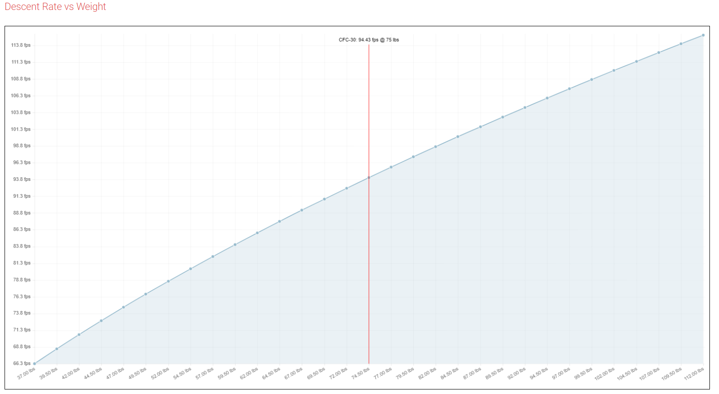

The Iris Ultra parachute comes standard with a 3000 lb. rated swivel and 400 lb. rated Paraline shroud lines. This parachute was chosen over different Iris Ultra parachutes on the website due its efficiency in price, space and strength. Other Iris Ultra parachutes that specialized in volume preservation or strength were not strong enough to withstand opening forces or over $200 more expensive. The Iris Ultra Standard parachute chosen for the main parachute provides a descent rate of 19.4 fps. This can be seen from the descent rate calculator from the Fruity Chutes website below.

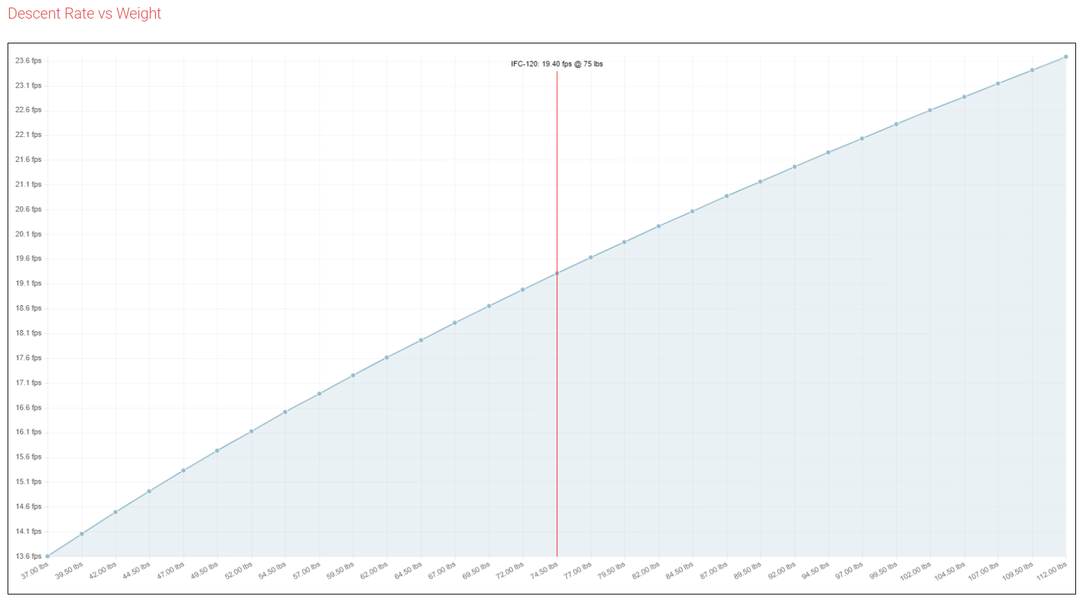

The CO2 Raptor ejectors were chosen as the method of detachment during flight over the traditional black powder method. Black powder has been reported as unreliable if the chambers are not properly sealed during flight. Some of the risks included in using black powder include, burnt parachutes, burnt shock chords/shroud lines and combustibility issues at high altitudes. The CO2 Raptor ejectors use a o-ring sealed compartment of black powder that is ignited via an electric spark to puncture a diaphragm and release liquid CO2 pressurized to 900 psi into the recovery section. The fumes from the black powder are exhaled through the same ports that the liquid CO2 is, this cools the fumes from the black powder eliminating the risk of burning holes in the necessary equipment for a successful recovery.

Two methods of parachute deployment were shown in the Design Requirement section of this report. The Recovery team has chosen to move forward with the Dual Deployment – Single Detachment high level design. This design was chosen because it is mechanically simpler than the Dual Deployment – Double Detachment method. This design is made possible by the purchase of the Tender Descender which holds the main parachute in its bay while the drogue is deployed and then releases the drogue parachute during the main parachute deployment. By eliminating the second detachment, less design needs to be done for the frame and recovery teams to ensure the detachment will work during flight. The single detachment method is also significantly cheaper than the dual detachment, costing $316 less without considering the additional cost of machining and mating components required for another section that can be detached.

Summary

Many components built into the Recovery system are contingent upon the final weight of the rocket. If the rocket weighs more or less than the diameter of the parachute can be decreased and the recovery section of the rocket can be shortened to preserve space. The major components required to build the recovery system have been chosen. While engineering support from Fruity Chutes has been used to pick out these components and assure that they will work as expected, more research into the governing laws is underway to provide more confidence in our design.